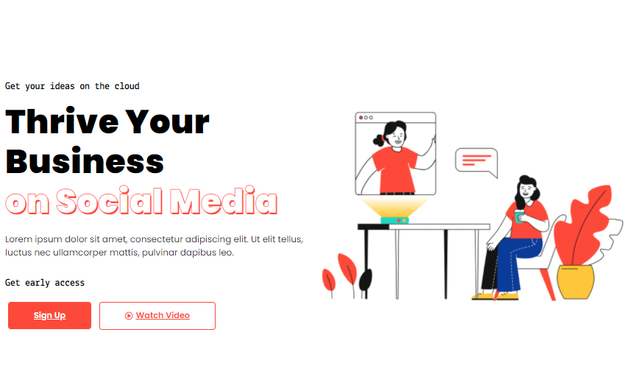
On our way to help your business reach out to all the global customers, making your business an online buzz game.

Want to know what your hot leads want from you? Don't worry, and we are here to back you up! Know your customers more efficiently with us.
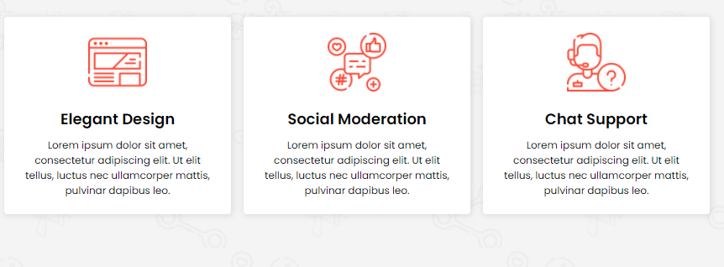
Elegant Design: Design is an integral part of grabbing your client's attention. Thus, give your website a proper look with efficient development.
Social Moderation- providing quality service is one of the things we prioritize most. Thus, it will be our responsibility to look after that as we are providing you quality service, you too are doing the same with your customers.
Chat Support- client satisfaction is mainly what we work for. Thus, we provide 24/7 chat support. Thus, we will be there to back you up whenever any problem arises.
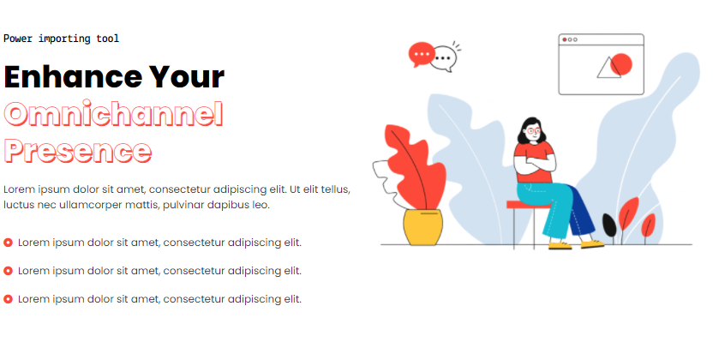
Our team is capable of handling large corporations and enterprises and being creatively mature enough to help start-ups and small firms grow and scale.
- We understand your demands, and thus we try hard to provide quality services
- Individual interactions with your customers
- Creating plans for your business to move strategically
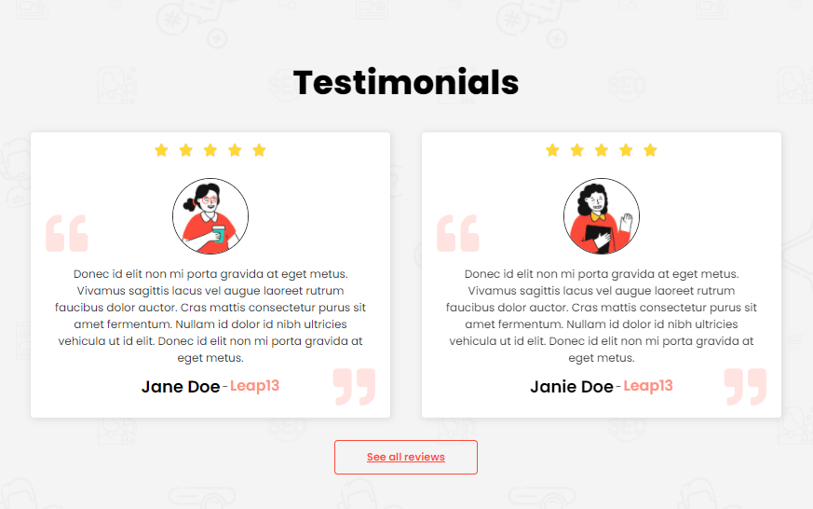
- Having an external marketing staff has always been difficult for me, but Digital Pracharak makes it seem and feel ridiculously simple and manageable.
- Aside from every fantastic digital pracharak they've sent us, I'll simply highlight their customer service. They are well-aware of what they are doing.
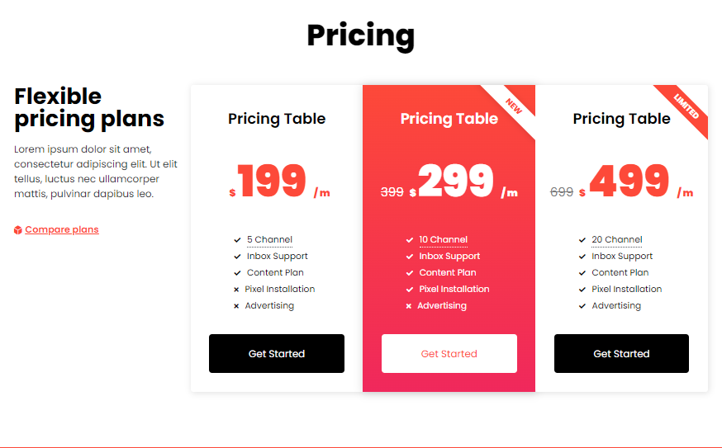
All our plans are affordable as we think about you. To know more about our plans, you can communicate with us through our official number or email id.

